Discovering a Sustainable Mindset [SysMind]

Result 1
Collection of Tools, Materials and Links towards the Development of a Sustainable Mindset and considering Cultural and Religious Diversity

July 2024

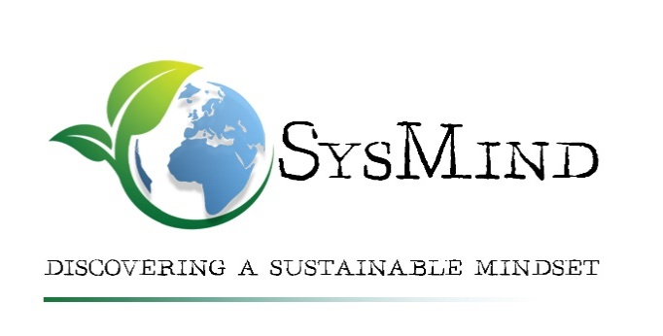



Table of contents

Introduction 3
Some interesting approaches and materials 3
Green Pedagogy 3
ProfESus - Discovering a sustainable mindset for a future-oriented lifestyle 5
The Diversity Wheel – A Tool for Diversity Management 6
The “Train the Trainer”-Approach 7
Good practice example: SusMind Expert Certificate 9
The Sustainability Mindset Approach 10
Inner Development Goals 11
Diverse sources for teaching materials on topics of sustainability 11
Links regarding cultural dialogue and spiritual/religious approaches 14
Other interesting links 16
Links concerning MOOCs and OER 17
Bibliography 17

Disclaimer:
The European Commission's support for the production of this publication does not constitute an endorsement of the contents, which reflects the views only of the authors, and the Commission cannot be held responsible for any use, which may be made of the information contained therein.

Introduction
The following compilation comprises different methods, approaches, information, and materials that may support teaching and training activities towards sustainability and enabling the development of a more sustainable Mindset.
Some of the presented approaches and materials were used to prepare the SysMind Curriculum and its implementation as Learning-Teaching-Training Activities. Some information and tools found their way into the “Developing A Sustainable Mindset-MOOC”, but you will also find other interesting and stimulating links.
We hope that this collection inspires and supports you for working with your learners, and also on your own journey towards a more sustainable mindset!

Some interesting approaches and materials

Green Pedagogy
Green Pedagogy was developed by the University College for Environmental and Agrarian Pedagogy in Vienna.
The key aspects of this pedagogical approach are that it….
- ... helps to develop models for sustainable lifestyles:
Agricultural and environmental education addresses new ideas and concepts of how diverse and sustainable agriculture can be in the future and deals with models for sustainable lifestyles.
- ... means active learning in a social exchange:
In the sense of Green Pedagogy, learning processes should be actively, self-directed and in exchange with others. Topics are dealt with according to their social relevance.
- ... avoids pigeonholing:
Linear cause-and-effect principles are no longer sufficient in a complex world. Exemplary problems are to be examined for different impact factors.
- ... irritates and enables to discover new things:
Irritation keeps people busy and generates curiosity. It asks for a solution. The goal is to exclude unreflective and one-sided considerations.

Therefore, it is a promising approach for any teaching and training activities aiming at developing a sustainable mindset under consideration of interculturality and interreligiousness.
Summary of the approach: https://www.haup.ac.at/wp-content/uploads/2019/10/Green-Pedagogy.pdf (English)
Publication Fox, A., Wogowitsch, C. (2021): “Green Pedagogy: Using confrontation and Provocation to promote Sustainability Skills”. In Hernández-Serrano, M.J. (2021): Teacher Education in the 21st Century - Emerging Skills for a Changing World. https://www.intechopen.com/chapters/75540
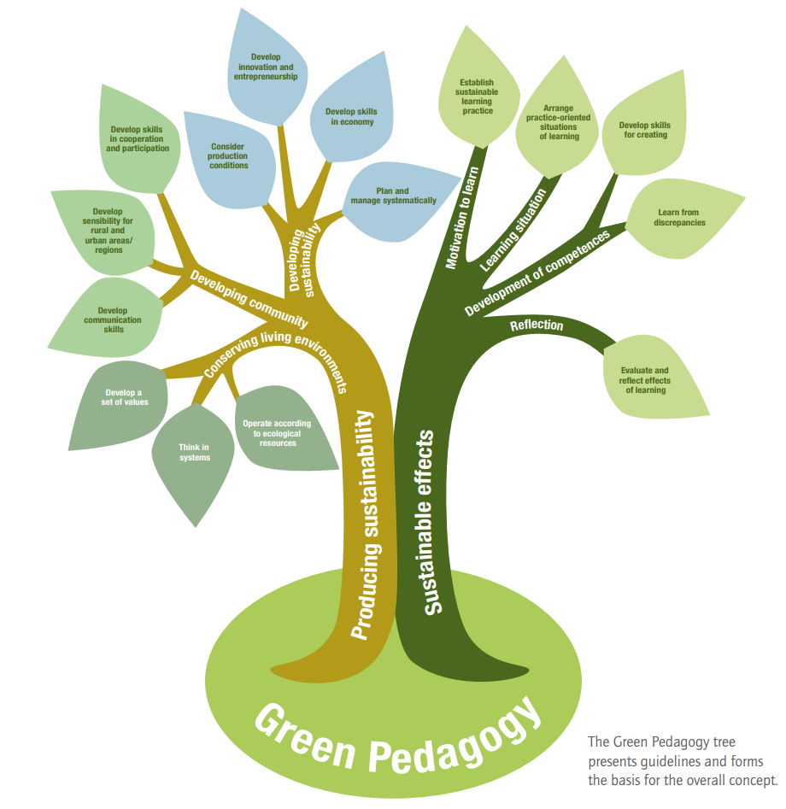
Figure 1: Green Pedagogy Tree

ProfESus - Discovering a sustainable mindset for a future-oriented lifestyle
This Erasmus Project was implemented from 2016 until 2019 and aimed at improving Education for Sustainable Consumption and Production in the context of professional home economic fields. The team developed a handbook and different materials like lesson templates and examples, a pedagogical approach, etc.
Project homepage: https://profesus.eu/outputs/english/
Handbook: https://profesus.eu/fileadmin/user_upload/Outputs/English/ProfESus_Handbook_web.pdf (English)

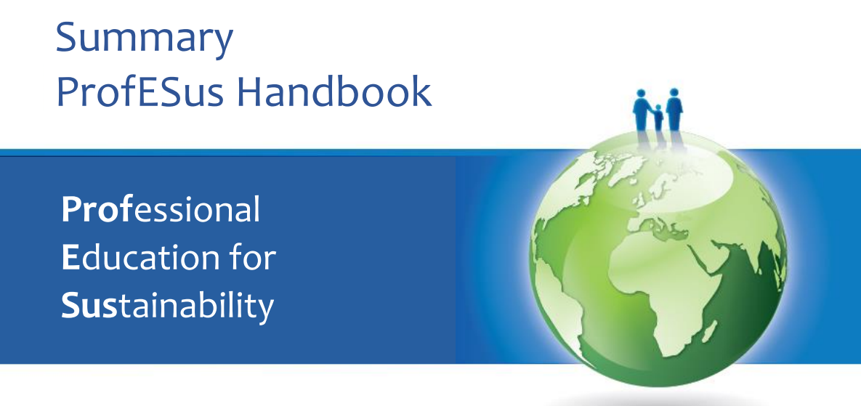
Figure 2: Detail from the Cover of the ProfESus Handbook

The Diversity Wheel – A Tool for Diversity Management
The diversity wheel, developed by Marylin Loden and Judy Rosener in the 1990s, is a very good tool to give an overview of the different dimensions of diversity people are facing in their environment:
  - Personality
  - Internal dimension
  - External dimension
  - Organisational level
All these dimensions are interrelated and interact with each other - this needs to be considered in a holistic and multidimensional teaching/learning approach. A short explanation can be found here What is diversity about? (univie.ac.at)
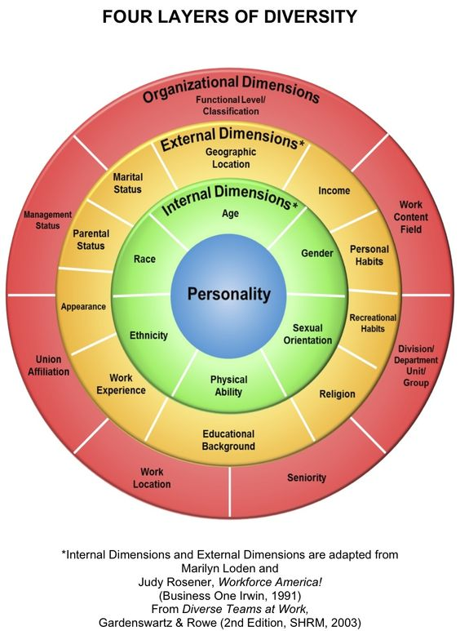
Fig. 3 Diversity Wheel (source: https://www.pinterest.at/pin/265642077996802409/)

The “Train the Trainer”-Approach
Fundacion Montemediterraneo, the Spanish project partner, developed this sensitisation method for trainers. It aims at letting teaching/training persons undergo a reflection themselves first to become aware of their own cultural/religious/spiritual backgrounds. This helps to deal with diversity when teaching ecological and sustainable topics to diverse groups.
- As a first step, pictures of representative scenes/persons are shown to the trainers, which have to deal with the following questions:
Look at the pictures and observe your reaction - what do you associate, what do you feel about the pictures?
This is taken as a starting point for discussion – where do you think your feelings come from? How do others feel when looking at the same picture? etc.
- The next step is the common definition of competencies teachers/trainers need in order to teach ecological and sustainable topics in groups with different cultural, religious and spiritual backgrounds, e.g.
  - Learn/Remember: Different cultural, religious, and spiritual backgrounds are possible
  - Understand where the students/pupils/apprentices come from, which are their backgrounds
  - Apply to the group/class to be taught – possible fields of conflicts
  - Analyse the different possibilities to access the contents
  - Evaluate which ways of access would link best to which background
  - Create an adequate method/exercise, etc.

As a last step, exercises, methods, programs, ideas, and strategies to teach sustainability/ecology are developed, taking in account the different cultural, religious and spiritual backgrounds of the students/pupils/apprentices. The whole process is depicted in Fig. 9:
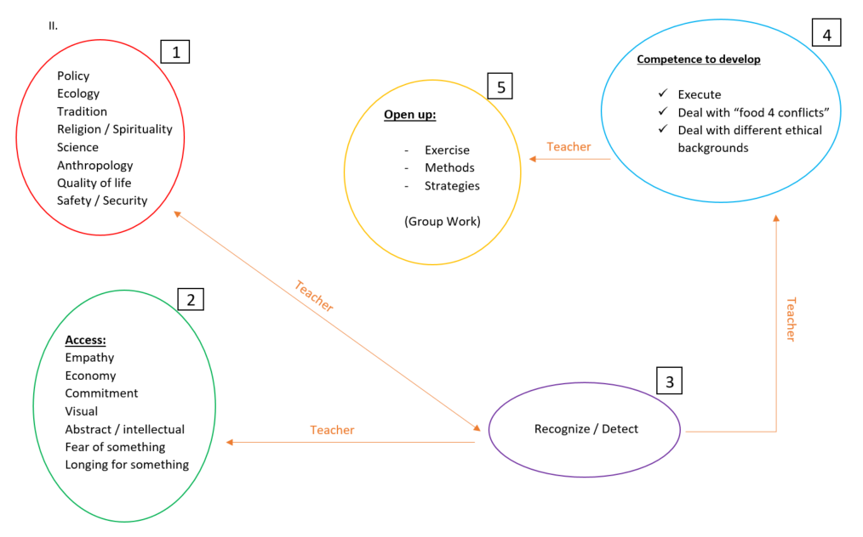
Fig.4 Process of Train the Trainer

Good practice example: SusMind Expert Certificate
Within the framework of PILGRIM, an international education network (PILGRIM – Strona internetowa poświęcona organizacji PILGRIM) which is aiming at the connection of sustainability topics with spirituality, a unique school project was developed: the “SusMind Expert Certificate”. The University College of Christian Churches of Teacher Education Vienna/Krems accompanied and supported these activities. The pupils are invited to focus on five out of 14 sustainability topics. Every topic comprises a bunch of tasks, from which the pupil again chooses 5. These tasks need to be fulfilled alone, with friends or support from the family. Solving the tasks is documented and afterwards the proof is given to the accompanying teachers. Finally, the pupil is officially called a SusMind Expert. This project trains and certifies pupils, who become “ambassadors” for a more sustainable lifestyle within their schools and families.
The materials are available in English: PILGRIM | SERVE THE WORLD | SUS - MIND - EXPERT (kphvie.ac.at)

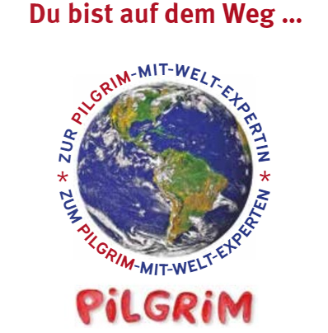
Figure 5: Logo of the German SusMind Expert Certificate

The Sustainability Mindset Approach
A group of scientists is working on the issue of a Sustainability Mindset since two decades and published several papers (Kassel et al., 2015; Rimanoczy and Klingenberg, 2021). According to them, a Sustainability Mindset is defined as „a way of thinking and being which results from a broad understanding of the ecosystem, social sensitivity, and an introspective focus on personal values and the higher self“ (Rimanoczy and Klingenberg, 2021).
They identified four content areas (Ecological worldview, Systems perspective, Emotional intelligence and Spiritual intelligence) and two ways of education for sustainability: the external perspective of knowledge, competencies, and skills providing information, models, benchmarks, and training) and the internal perspective of individual values, beliefs, assumptions, etc.
According to them, the following 12 principles are the scaffolding for educators to design learning interventions:
Tabelle 1: 12 Principles for a Sustainability Mindset
Ecoliteracy | Cyclical flow | Oneness with Nature
My contribution | Creative innovation | Purpose
Long-term thinking | Reflection | Interconnectedness
Both-and thinking | Self-Awareness | Mindfulness

A specific indicator system was also elaborated: https://smindicator.com/. Here, you can find some information on the development of the indicators, published in a scientific paper: Rimanoczy_Klingenberg_JMGS_SMI.pdf (smindicator.com)

Inner Development Goals
The Inner Development Goals were developed to supplement the Sustainable Development Goals (SDGs), when it became obvious that for the achievement of the SDGs, a personal development process in humans seems to be necessary Inner Development Goals – Inner Growth for Outer Change. You can find some more information about the IDGs here: IDG.tools - Inner Development Toolkit - Change starts within;

Diverse sources for teaching materials on topics of sustainability
- The Austrian Forum Umweltbildung [Environmental Education] About us – Forum Umweltbildung offers a few teaching and information materials in English (see link before) and also a lot of materials, podcasts, education offers, etc. in German Forum Umweltbildung – Österreichisches Portal für Umweltbildung und Bildung für nachhaltige Entwicklung
- The Sustainicum Collection contains teaching resources, units and methods from the University of Applied Life Sciences Vienna. It also gives the opportunity to share own teaching materials: Home - Sustainicum Collection
- Ecological footprint: to use the ecological footprint as an awareness tool, it is advisable to gain more information about how to interpret and work with it (key words: grey footprint, national specifics, etc.). You can find some more information on Home - Global Footprint Network , especially under Footprint-Limitations-and-Criticism.pdf (footprintnetwork.org) or also in the Course: Discovering a Sustainable Mindset-MOOC | iMooX
Here, you can calculate the environmental footprint of your company’s equipment fleet. https://greenit.ee/en/calculator/. Under Sustainability Guide | Software AG, the necessity of sustainability is described from an enterprise´s point of view.
- BLOOM-Schoolbox: A project of the European Schoolnet in Brussels.
The Boom-Schoolbox is a collection of bioeconomy related teaching resources which educators can use to introduce the concept of bioeconomy in their classrooms. https://bloom-bioeconomy.eu/schoolnetwork/schoolbox/

- The Method Bag: The University College of Environmental and Agrarian Pedagogy Vienna has collected different methods for adult training.
  - Methoden BAG – Bildung aktiv gestalten mit Methoden für die Erwachsenenbildung [Actively designing Education for Adults], Youtube: Methoden BAG - YouTube (German, English translation planned – you may use auto-translated subtitles if possible)
- ProfESus Learning Activity Plan/Lesson example (https://profesus.eu/fileadmin/user_upload/Outputs/English/Learning_Activity_Plan_ProfESus_example.pdf)
- Green Pedagogy teaching units (German and partly English): https://www.haup.ac.at/forschung-projekte/unterrichtsmaterialien/)
- The Baltic University Programme (https://www.balticuniv.uu.se/education/course-platfom/)
- The Erasmus+ KA2 project AgriTrain developed material for the “training of trainer”: trainers are trained to implement more sustainability in their teachings and training. AgriTrain includes the material of a former Erasmus+ KA2: AgriSkills, together with material for students, pupils, and trainees to implement more sustainability in livestock breeding, mainly pigs and cattle. AgriTrain – Growing to be sustainable in agriculture! (agri-train.eu)

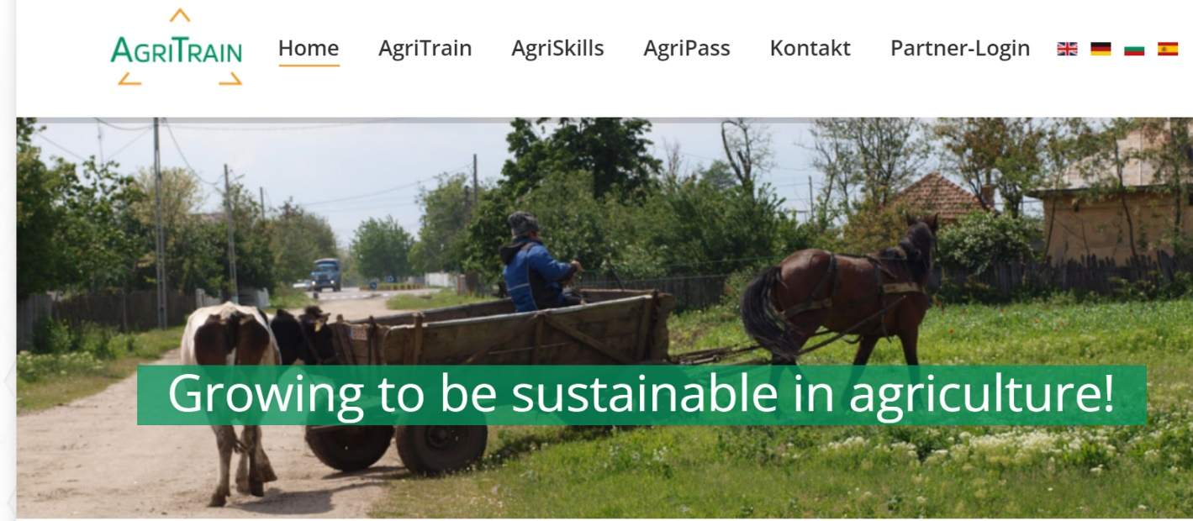
Figure 6: Screenshot project Website AgriTrain
- 6 types of easily applicable experiment settings prepared for an Erasmus + Project (Enhanced Capacity of the Youth on Biobased Economy) output to make children and youths aware of sustainability and circular economy: https://www.bioyouth.org/outputs/
- 10 short online lectures prepared by a university professor prepared for an Erasmus + Project (Enhanced Capacity of the Youth on Biobased Economy) output to make children and youths aware of sustainability and circular economy: https://www.utemooc.org/courses/enhanced-capacity-of-the-youth-on-biobased-economy/
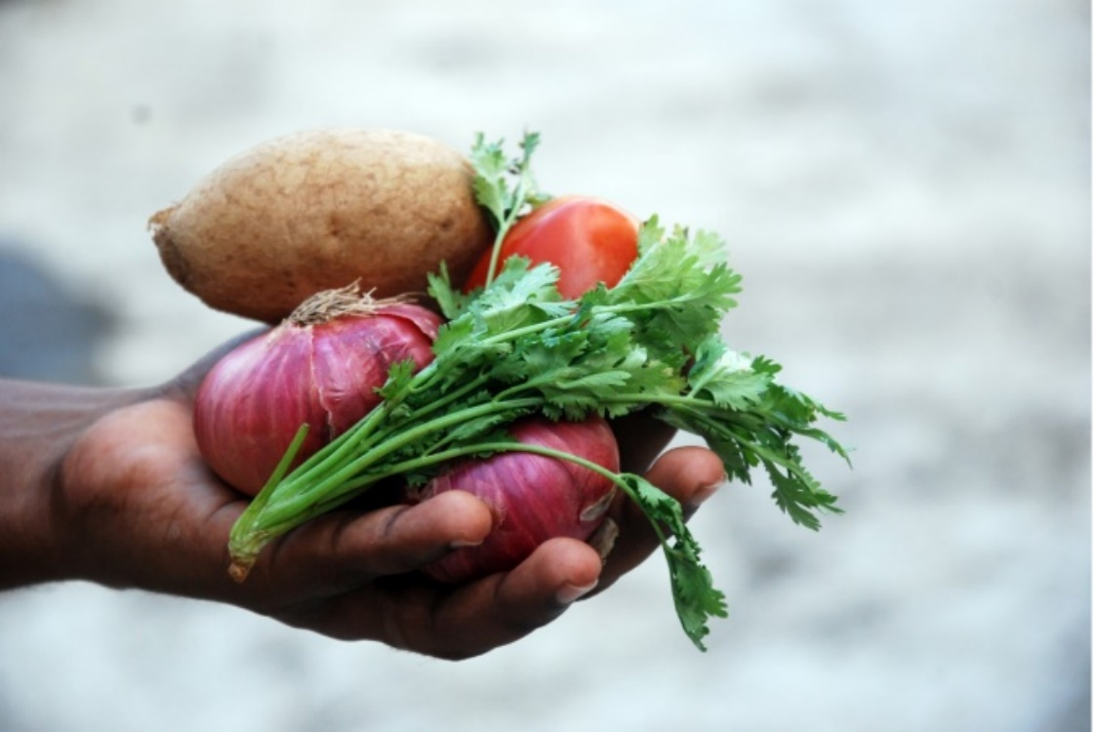
- Guidance for adults to be aware of sustainable food system, and list of what can be done and adult education tools ? (prepared by Erasmus + Project (FOODTR Project): FOODTR - Increasing Food-Literacy Competencies of Adults
Figure 7: Vegetables, source: Free Images : hand, plant, flower, food, produce, vegetable, potato, vegetables, ingredients, onions 3872x2592 - - 987945 - Free stock photos - PxHere

Links regarding cultural dialogue and spiritual/religious approaches
- UNESCO information: What is Intercultural Dialogue | e-Platform on Intercultural Dialogue (unesco.org); related publication: We need to talk: measuring intercultural dialogue for peace and inclusion - UNESCO Digital Library
- Some further information by the UNESCO:
  - on how culture contributes to development UNESCO Culture for Development Indicators (CDIS) | Diversity of Cultural Expressions and the implementation toolkit UNESCO culture for development indicators: implementation toolkit - UNESCO Digital Library
  - Culture and public policy for sustainable development, Forum of Ministers of Culture, 2019 - UNESCO Digital Library
- The concept of intercultural dialogue (European Council): coe.int/t/dg4/intercultural/concept_EN.asp
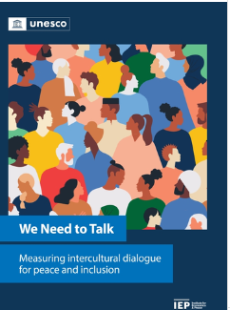
- Dialogue as a concrete way: Interreligious Dialogue and Cooperation | World Council of Churches (oikoumene.org)
Figure 8: Cover of the Unesco publication: We need to talk
- A forum for academic, social, and timely issues affecting religious communities around the world, providing peer-reviewed publications: Journal of Interreligious Studies (irstudies.org)
- An international multireligious project of the Yale University Front Page | Yale Forum on Religion and Ecology
- A European Initiative: About the Forum - Official website of the EFSRE (religion-environment.com)
- UNEP publication: Faith for Earth: A Call for Action | UNEP - UN Environment Programme
- Paper about Islam and Sustainability: An Islamic Perspective on Ecology and Sustainability | IntechOpen
- Edited Book: Ecotheology – Sustainability and Religions of the World by L. Hufnagel Ecotheology - Sustainability and Religions of the World | IntechOpen
- Another Article about Muslims and Ecology: (PDF) Muslims and ecology: Fostering Islamic environmental ethics (researchgate.net)
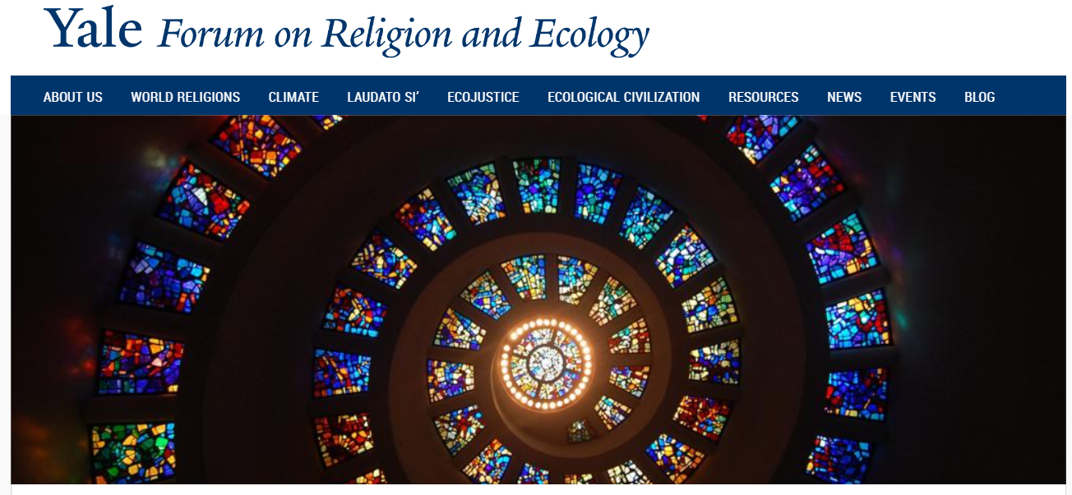
- Encyclical Letter by Pope Francis: Laudato si' (24 May 2015) | Francis (vatican.va)
- Article about the role of religions for sustainability: Religious repertoires of sustainability: Why religion is central to sustainability transitions, whatever you believe - ScienceDirect
Figure 9: Screenshot Front Page | Yale Forum on Religion and Ecology

Other interesting links
- The 2030 Agenda is not an instruction manual on how to achieve the 17 Sustainable Development Goals. Rather, it is a compass. People should have relevant information and awareness of sustainable development by 2030 - across the world. https://www.eda.admin.ch/agenda2030/en/home/agenda-2030/die-17-ziele-fuer-eine-nachhaltige-entwicklung.html
- GreenComp identifies a set of sustainability competencies to feed into education programs to help learners develop knowledge, skills and attitudes that promote ways to think, plan and act with empathy, responsibility, and care for our planet and for public health. GreenComp: the European sustainability competence framework - European Commission (europa.eu)
- The Website Sustainability - The Great Dilemma (sustainability-yes.ch) is about sustainability and contains ideas, informative links and videos:
  - Sustainability - What Can I do? (sustainability-yes.ch)
  - Sustainability - What Can We Do? (sustainability-yes.ch)
- Striving for a common and ethical ground that serves all forms of life: World Ethic Forum – Symposium for Meaning, Responsibility and Transformation
- What is Türkiye doing for sustainable food production? 2021-12-22-en-designed-edition-booklet-national-pathway-of-turkiye.pdf (unfoodsystemshub.org)
- What can Türkiye do to fight climate change which is prepared for an IPA Project about environmental issues of sustainability? https://www.iklimiduy.org/
- What can a retail do for sustainability, for reduction of food waste? Retailer’s guidelines:
  - https://furtherwithfood.org/resources/retail-food-waste-action-guide/
  - https://refed.org/downloads/Retail_Guide_Web.pdf
  - https://www.wrap.ngo/resources/report/reducing-household-food-waste-and-plastic-packaging

Links concerning MOOCs and OER
- SysMind project result: Discovering a Sustainable Mindset-MOOC | iMooX
- A free course about “Exploring Sustainability”: The Baltic University Programme (canvaslms.com)
- Some information about OER: What are Open Education Resources? - Open Educational Resources (OER) - Research Guides at Harvard Library
- Public Digital Library of open educational resources: OER Commons
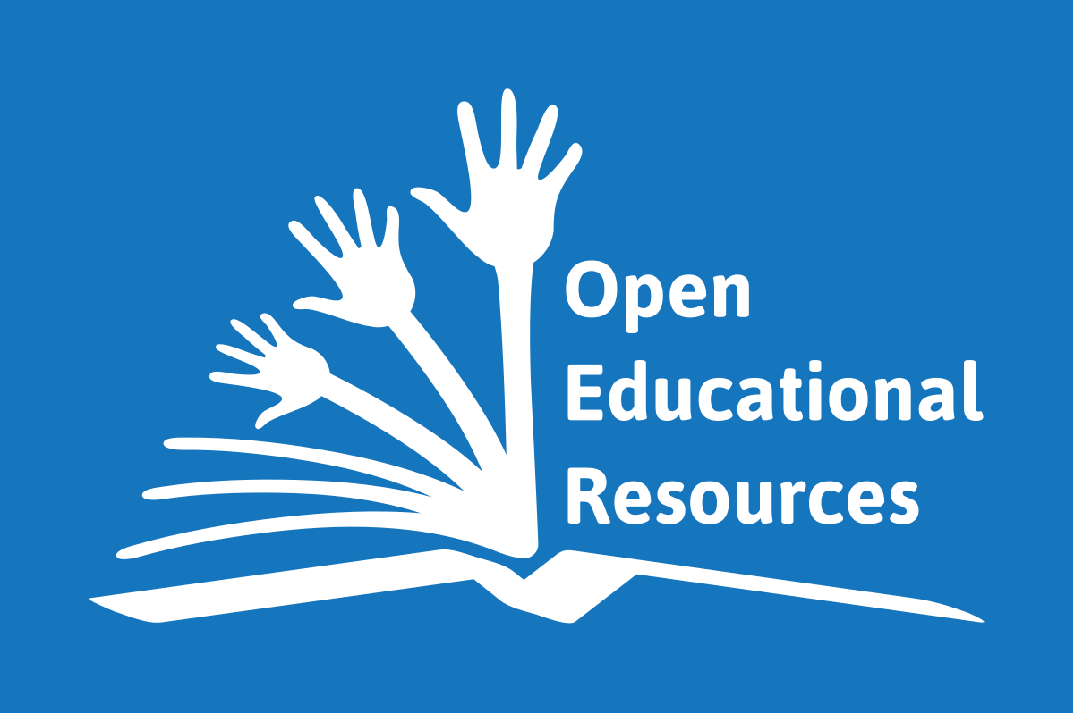
Figure 10: Source File:Global Open Educational Resources Logo.svg - Wikimedia Commons

Bibliography
Kassel, K., Rimanoczy, I., Mitchell, S., 2015. A Sustainability Mindset Model for Management. Acad. Manag. Proc. 2015, 13850–13850. https://doi.org/10.5465/AMBPP.2015.13850abstract
Rimanoczy, I., Klingenberg, B., 2021. The Sustainability Mindset Indicator: A Personal Development Tool. J. Manag. Glob. Sustain. 9, 43–79. https://doi.org/10.13185/JM2021.09103

